*To use this document, first read the* [*Instructions and FAQs*](https://docs.google.com/document/d/1yXJCV3nyrI8o8YuDuVICXz13nWeJKOrlampQ8ifLkG0/edit)*. This document is licensed by the Howard Hughes Medical Institute under a* [*Creative Commons Attribution-NonCommercial-ShareAlike 4.0 International license*](https://creativecommons.org/licenses/by-nc-sa/4.0/)*. No rights are granted to use HHMI’s or BioInteractive’s names or logos independent from this document or in any derivative works. Using this document, you agree to use this document in accordance with these terms.*

# INTRODUCTIONAn underwater photograph of a coral reef showing various species of corals of different colors, sizes, and shapes and fish swimming among them.

Coral reef ecosystems are in trouble. About 20% of the world’s coral reefs have already been lost, and that number may climb to 50% in the next 20 to 40 years. The main culprits are pollution, overfishing, and climate change. In this activity, you will use satellite data to determine threats to coral reef ecosystems from warming ocean water.

# BACKGROUND

### What are corals?

Although they may look like plants or rocks at first glance, corals are animals related to jellyfish and anemones. Individual corals are called **polyps** and, in many species, form colonies of identical clones. Polyps secrete a hard calcium-based skeleton that creates the physical structure of coral reefs. Reef-building corals have a limited ability to acquire food and nutrients on their own, so they rely on intracellular symbiotic algae (**symbiont**) that supply sugars and oxygen produced via photosynthesis.

### Why study corals?

Coral reefs are a critical marine habitat, accounting for 25% of marine biodiversity even though they only occupy 0.015% of the ocean. Five hundred million people depend on coral reefs for food sources, coastal protection, building materials, and income from tourism. The net value of coral reef ecosystems has been estimated to be almost $30 billion per year.

### What is coral bleaching?An underwater photograph of a bleached coral. It has lost all its color and appears white.

Elevated temperatures can damage the photosynthetic system of the symbiont, causing them to create reactive oxygen molecules that can damage the coral cells. Corals respond by ejecting the symbionts, without which the polyps are colorless and the coral reef appears white (Figure 2). This is called **bleaching** and is a serious threat to the health of the coral reefs. Corals can survive without symbionts for short periods of time and can reacquire symbionts when heat stress subsides. However, if the bleaching is prolonged, the coral will likely die.

### When does bleaching occur?

Heat stress makes corals vulnerable to bleaching. Generalizing about the amount of heat stress that corals can withstand is complicated because they are adapted to local environments and are somewhat able to acclimate to changing environments. One method to determine whether a coral is at risk of bleaching is to record when temperatures rise 1°C or more above the normal maximum for a given location. For purposes of tracking coral health, normal temperatures are determined by averaging monthly temperatures for 1985 to 1993. The warmest normal temperature is the month with the highest average temperature, called the **maximum monthly mean** **(MMM)**. The temperatures are measured by satellites using an infrared radiation sensor and represent **sea surface temperature** **(SST)**. Only nighttime data are used to avoid overestimating heat due to solar heating of a thin layer at the sea surface.

Heat stress is assessed by a measure called **degree heating weeks** **(DHW)**. It is a cumulative measurement of the intensity and duration of heat stress that a coral reef experiences over a period of 12 weeks, equivalent to a season. Empirical observations suggest that bleaching occurs when four DHW accumulate within a 12-week window, and coral death occurs when DHW values are greater than 8. Because heat tolerance can vary within and among different coral species, these DHW thresholds are merely guidelines; some corals may survive in areas with high heat stress, while others may perish with relatively mild stress. Further, the temperature data is averaged over relatively large areas of 5 km2, but actual temperatures experienced by corals may vary greatly due to local conditions. Finally, corals can recover after the stress disappears, and the 12-week window accounts for this.

# MATERIALS

* a “Location Card” from your instructor
* access to a spreadsheet program (Microsoft Excel, OpenOffice, etc.)
* copies of world maps

# PROCEDURE

This activity includes temperature data for 28 different coral reef locations. Your instructor will assign you a specific location by giving you a “Location Card.”

1. Download the data file for your assigned location from the [Coral Temperature Data](https://www.biointeractive.org/coral-temperature-data) page. The name of the data file will match your location and should be indicated on your card.
2. Graph the data using a spreadsheet program.
   1. Instructions for making the graphs in Microsoft Excel and OpenOffice are at the end of this handout.
   2. You should make **three graphs**, each covering two years of data.

Next, you will estimate the number of **degree heating weeks (DHW)** for specific years. To calculate the number of DHWs, count the boxes under every curve above the MMM that appears during that year. For instance, 1°C above the MMM for 1 week is 1 DHW, 2°C above the MMM for 1 week is 2 DHW, and so on. Figure 3 shows several examples.



Below is an example of a temperature graph for Beqa, Fiji. In this example, the cumulative DHW in 2002 is greater than 8, so it is likely that corals at this location experienced bleaching severe enough to kill them.



1. Using the examples above as a guide, calculate the DHW values for your location in the years **2002**, **2010**, and **2014**. Count all the DHWs within a 12-week window (calendar dates will vary from site to site). *Tip*: If the season spans January 1, then assign it to the year in which most of the heat stress occurs. For example, the 2002 hot season may actually start in December of 2001.
   1. Use the following table to assign the **risk level** for your location for 2002, 2010, and 2014. As shown in the table, when DHW is greater than 8, coral mortality is likely and you can stop counting DHWs.

| Location: |  |  |  |  |
| --- | --- | --- | --- | --- |
| Latitude: |  |  |  |  |
| Longitude: |  |  |  |  |
| Year | **Risk Levels** | | | |
| **No Bleaching** (DHW = 0) | **Bleaching Possible** (0 < DHW < 4) | **Bleaching Likely**  (4 ≤ DHW < 8) | **Mortality Likely** (DHW ≥ 8) |
| 2002 |  |  |  |  |
| 2010 |  |  |  |  |
| 2014 |  |  |  |  |

* 1. Find your location on the world maps provided by your instructor. Indicate the risk level at your location for the corresponding years, using stickers or colored pencils as directed by your instructor.

# QUESTIONS

Use the completed world maps to answer the following questions.

1. After analyzing the world maps, what patterns, differences, or similarities do you notice between the different years represented?

|  |
| --- |

1. What geographic patterns do you notice? Are there regions of the globe that are more prone to bleaching than others?

|  |
| --- |

1. Is there a global trend from 2002 to 2014? Explain.

|  |
| --- |

# Graphing Directions for Microsoft Excel

These directions are for Excel for Mac in Office 365. Other versions will also work but might look different.

1. Open Excel, and then open the data file for your location.
2. Select the date and sea surface temperature (SST) columns that you wish to graph. Click on **“Insert”** from the menu bar, then **“Chart,”** then **“Line**.” 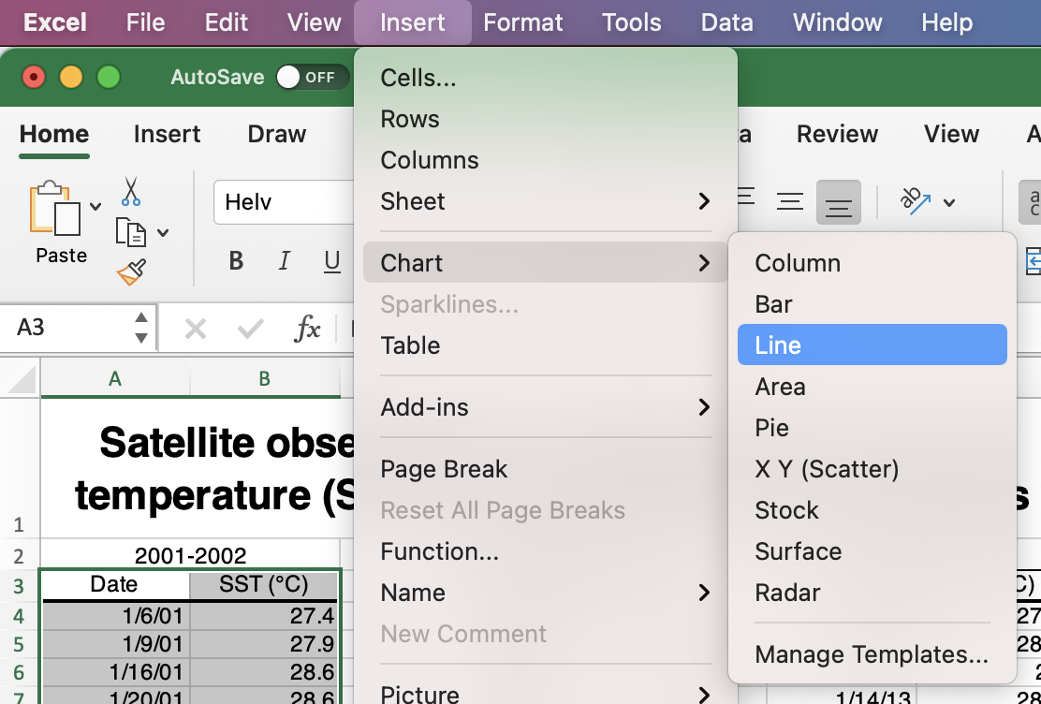
3. Double-click on the *y*-axis. Set **“Minimum”** to the MMM for your location. Set the **“Major”** unit to 1.

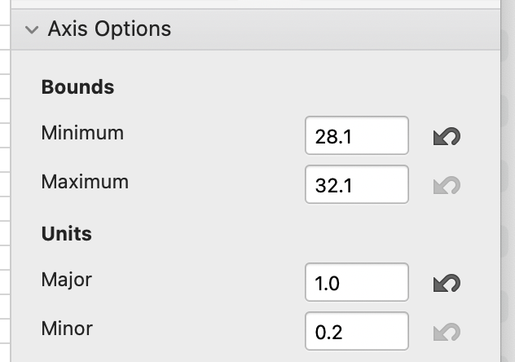

1. Double-click on the *x*-axis. Set **“Major”** unit to 7 days (1 week). You may wish to stretch the graph out to make the labels easier to read.
2. Show the major *x*-axis gridlines by right-clicking the *x-*axis and selecting “**Add Major Gridlines**.”  
   An example of a final graph is shown below.

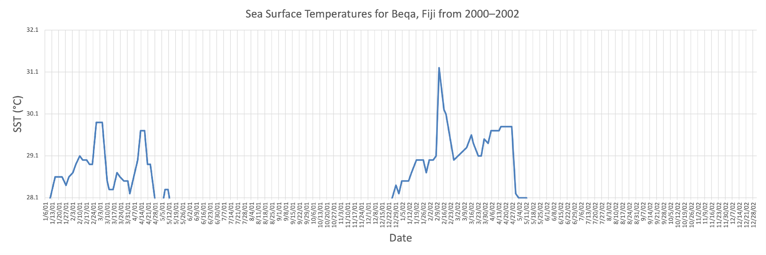

# Graphing Instructions for OpenOffice

[OpenOffice](http://www.openoffice.org/) is a free software with a spreadsheet application. These directions are for Version 4.1.10 of OpenOffice on Mac. Other versions will also work but might look different.

1. Open OpenOffice, select the **“Spreadsheet”** option, and then open the data file for your location.
2. Select the date and sea surface temperature (SST) columns that you wish to graph, then click on the **graph icon** on the menu bar. 
3. Choose **“XY (Scatter)”** as the chart type and then **“Lines Only.”**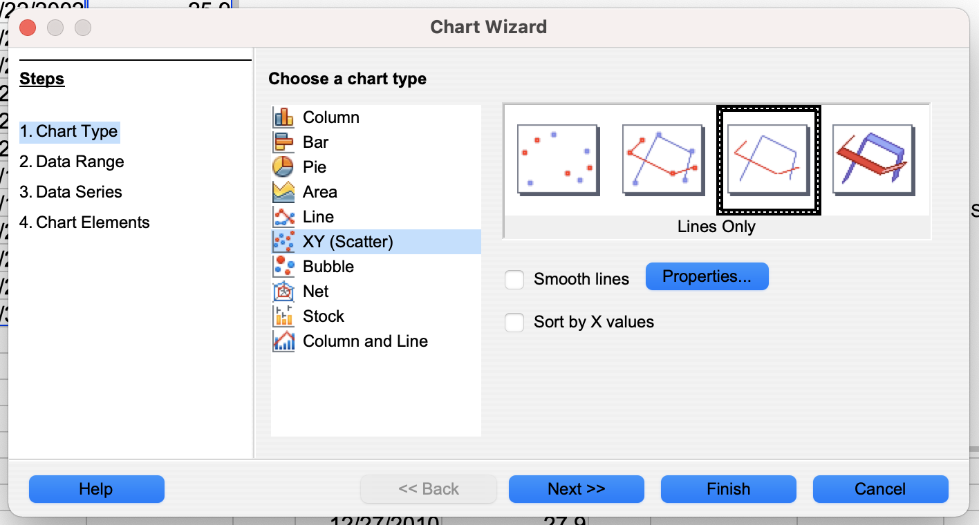
4. Double-click on the *y*-axis. Set **“Minimum”** to the MMM for your location. Set **“Major interval”** to 1.

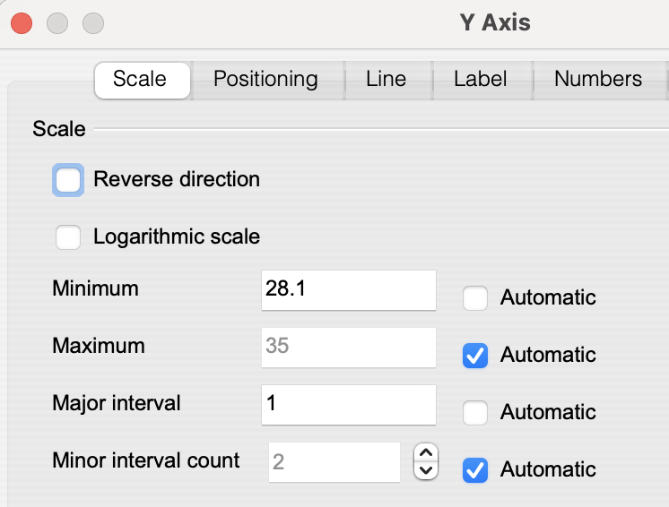

1. Double-click on the *x*-axis. Set **“Major interval”** to 7 for 7 days (1 week). You may wish to stretch the graph out or to rotate the axis labels under “Label” on the axis-formatting pane.
2. Show the major *x*-axis gridlines by selecting “Insert” and then “Grids” from the top menu.

An example of a final graph is shown below.

